User Documentation

System Overview
The system is designed to make renewing your personal ID easier and faster. It lets citizens submit renewal requests online, upload the required documents, pay any fees, and track the status of their requests in real-time. Government employees can review requests, update the status, and ensure everything is processed correctly. Administrators and auditors can oversee the whole process, generate reports, and ensure that all data is secure and accurate.
Basically, it’s a digital system that keeps everything organized, from citizen information to payments, so everyone knows what’s happening at each stage of the ID renewal process.

Using the system
Admin firstly will log in that enter the user name and the password :
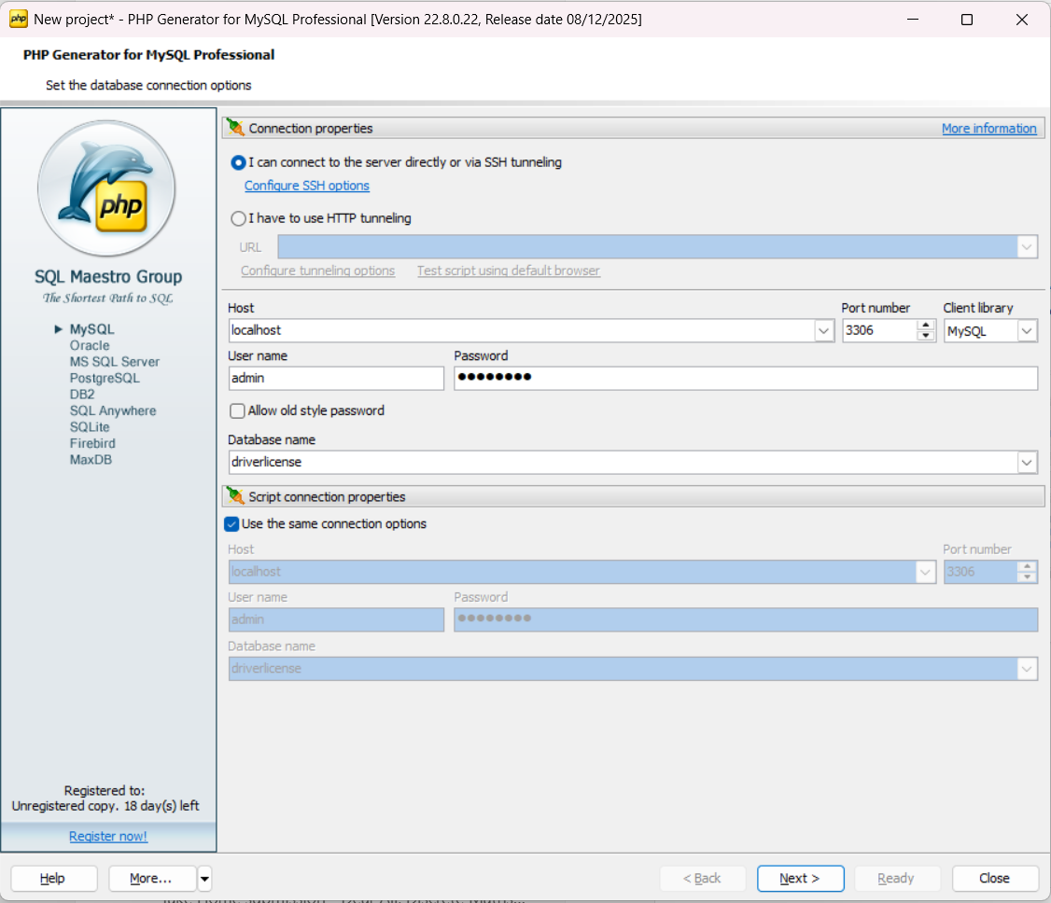
Click on the link below to open the website in your browser:
http://localhost/sanad/
Admin can moves form pages by clicking on the name of the page he want from here:
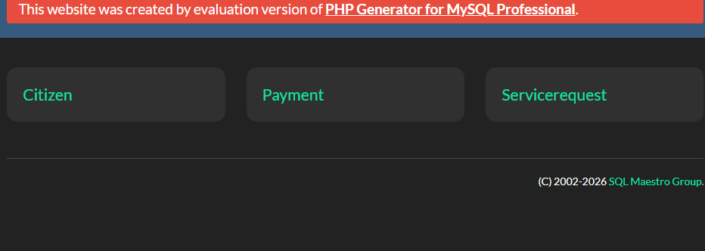

Add New Citizen
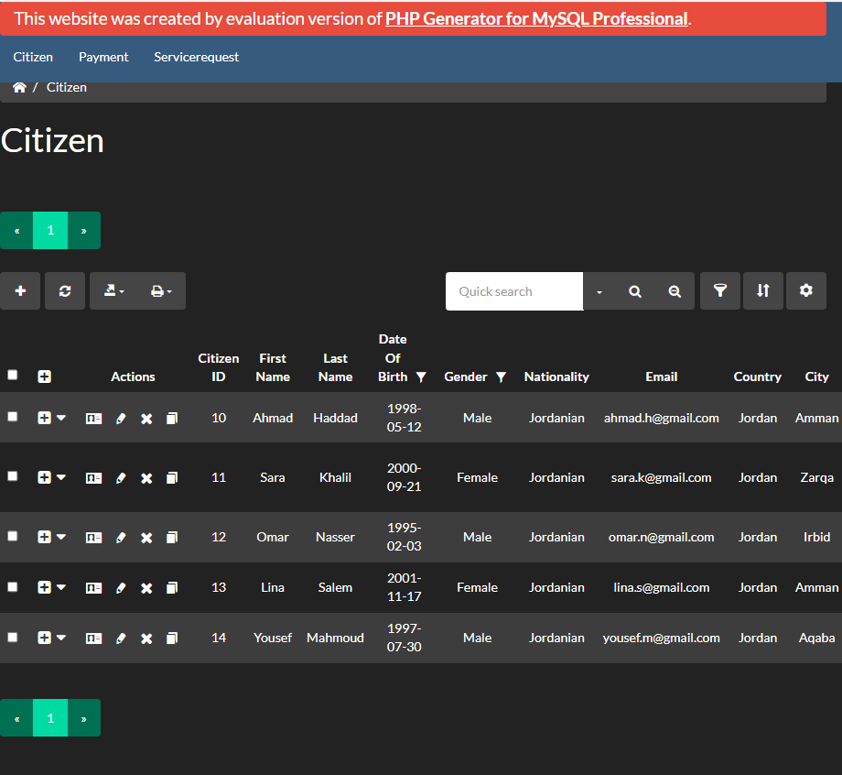
Enter citizen information & save
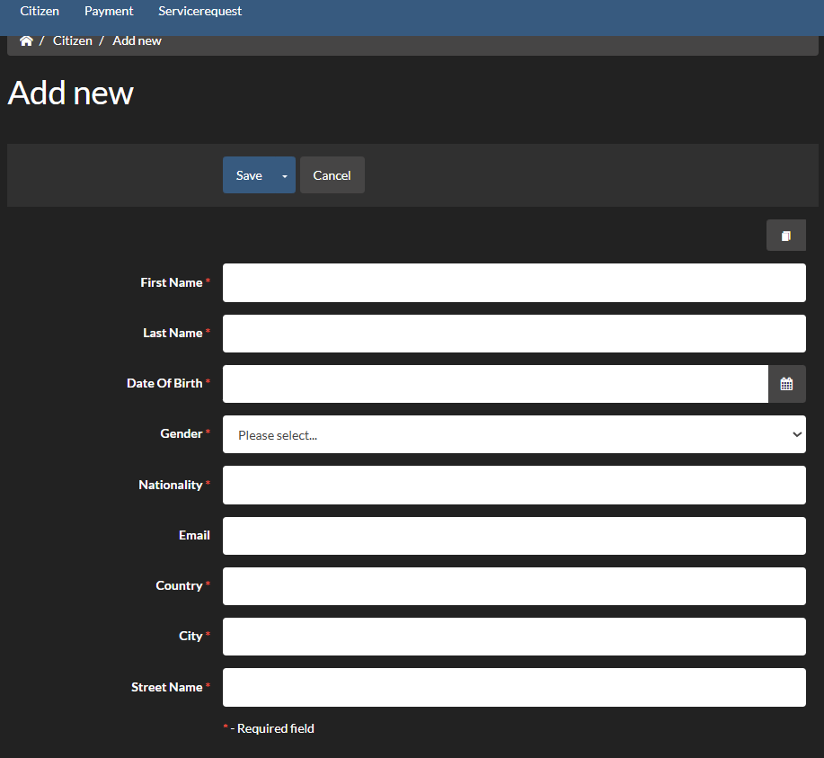

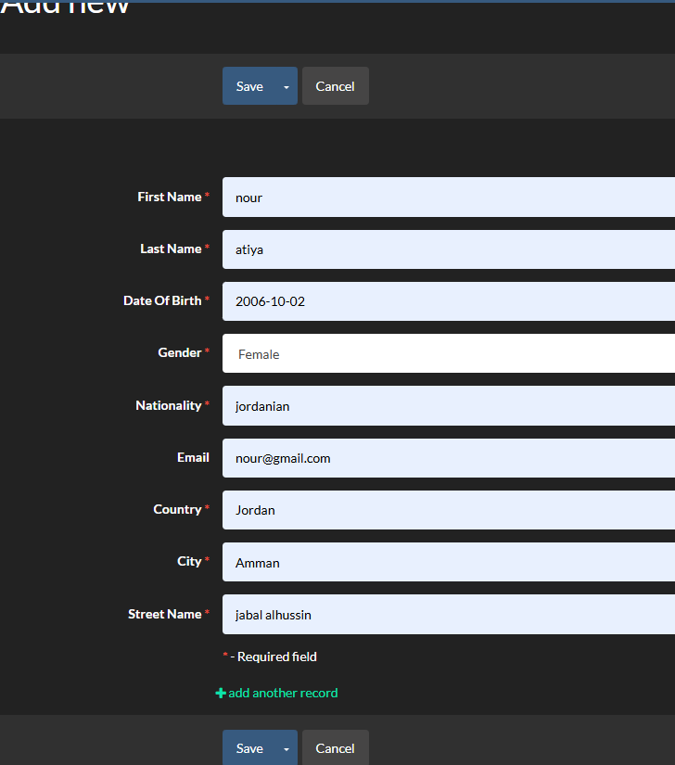
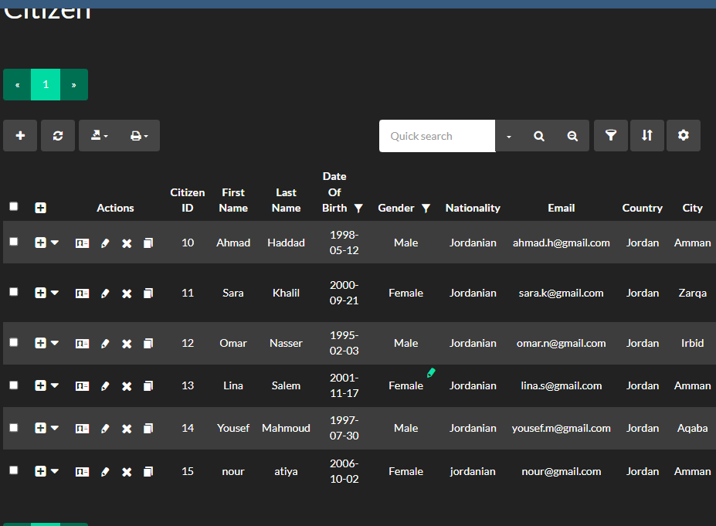 the new citizen

Edit Citizen
Edit the info & save it
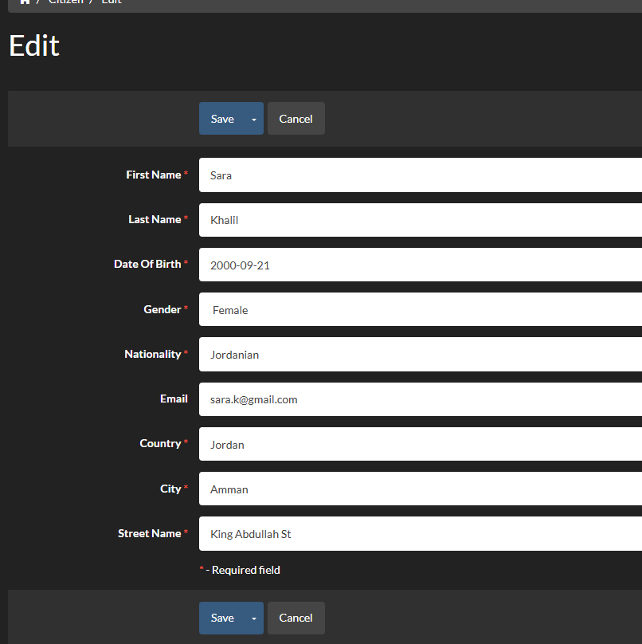 the country after edited

Delete Citizen
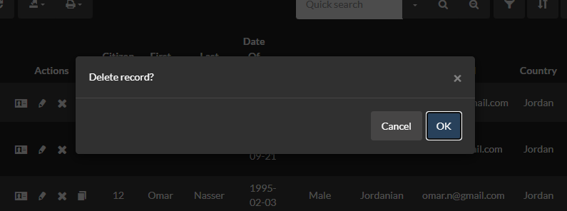

Then the citizen is deleted:
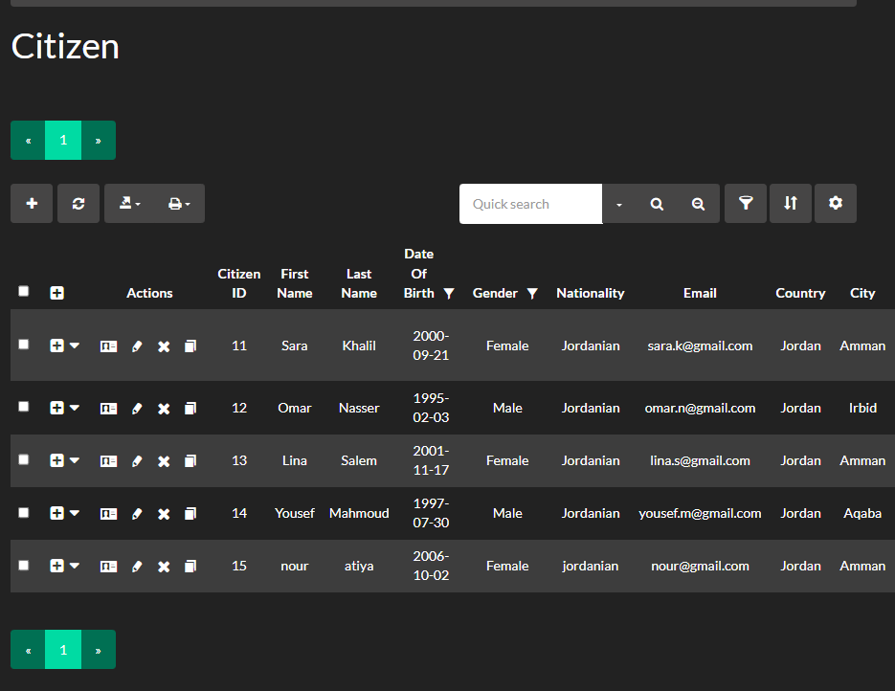

View Citizen
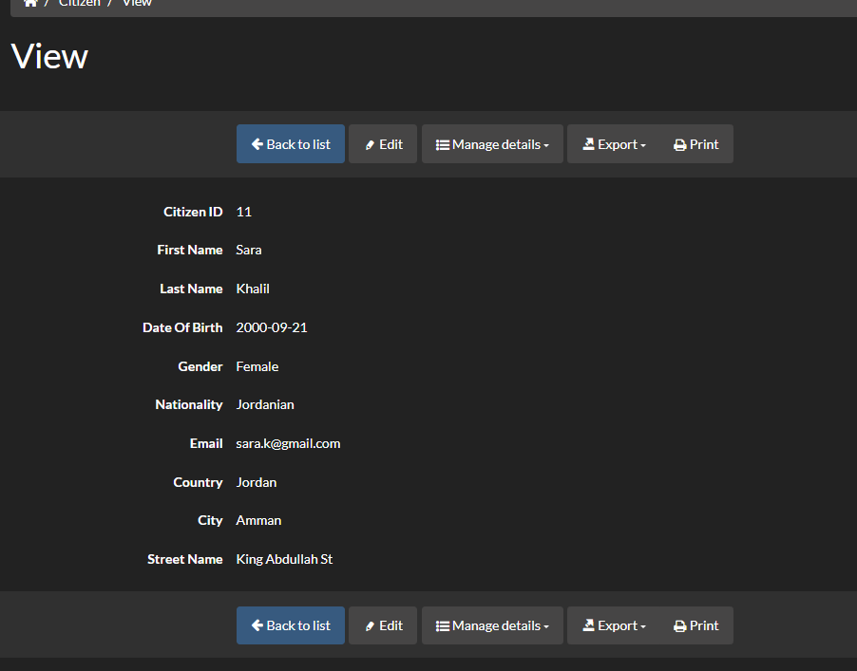
You can also export the citizen information
Then chose the type
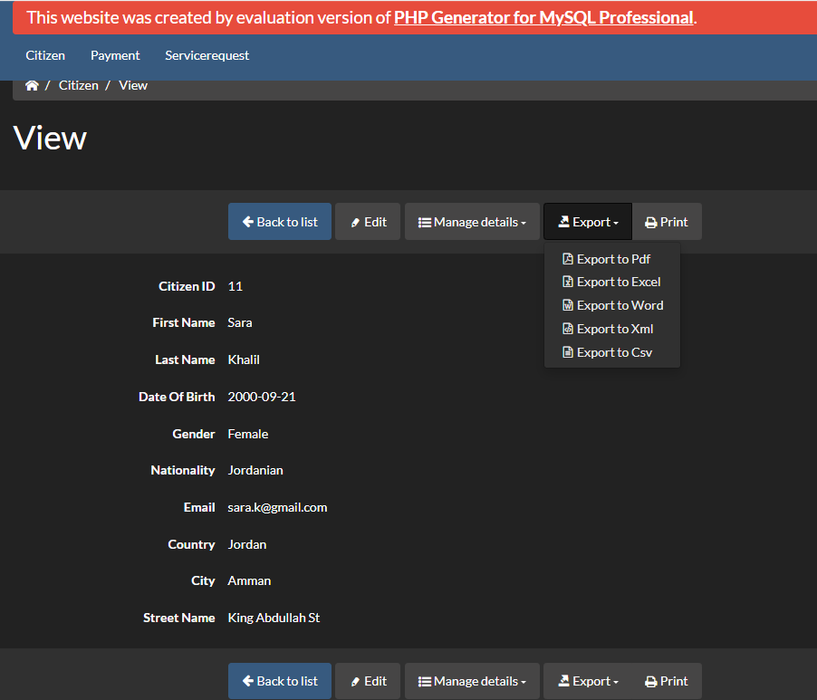
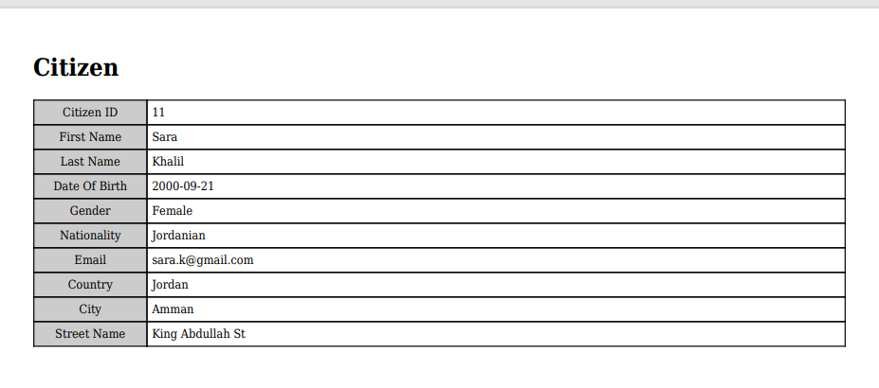
Export all Citizen data
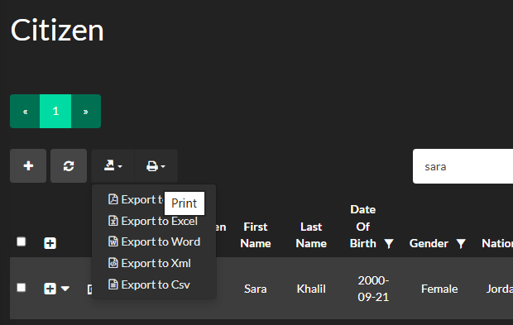
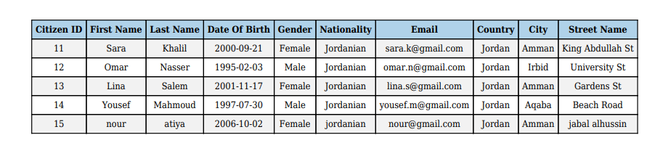
You can also filter Citizen
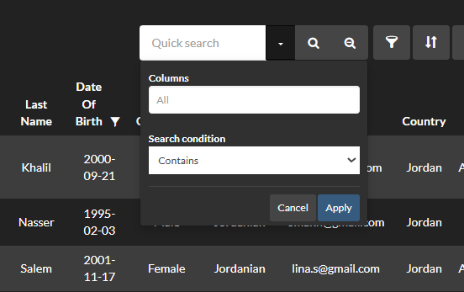
You can choose the column name
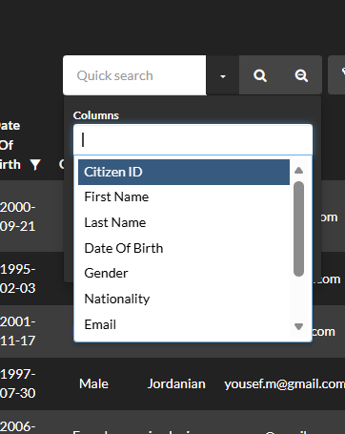
You can choose the condition
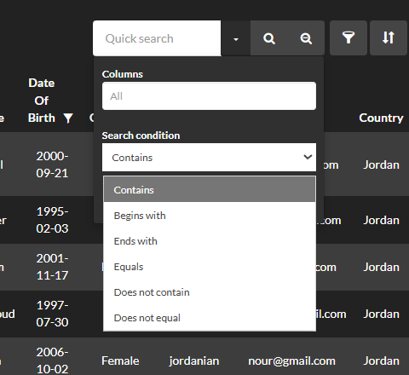
Then apply
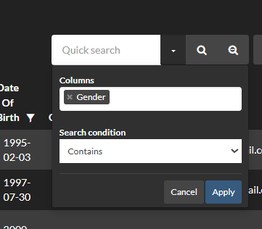
can also filter Citizen by Quick search
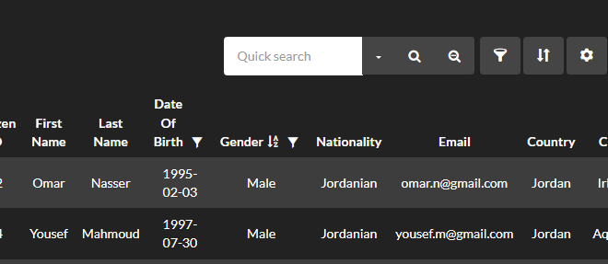
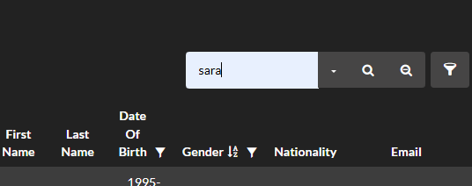

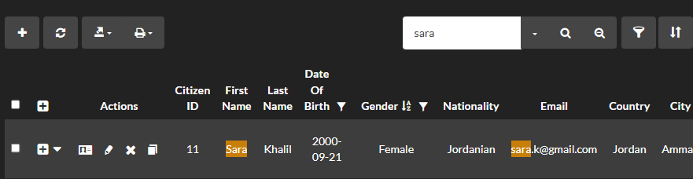
can also remove filter Citizen by click on
can also build filter Citizen
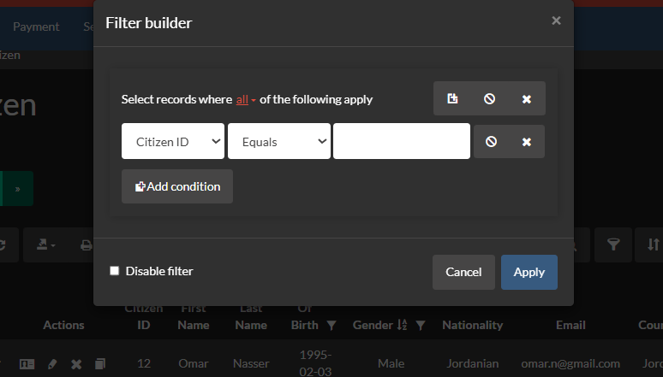
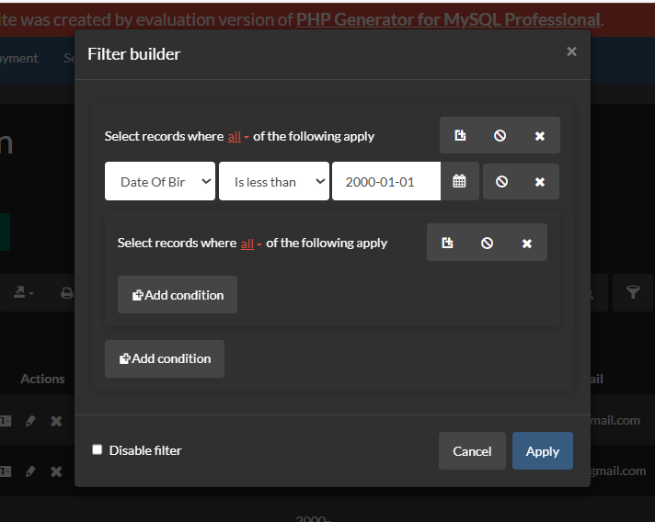
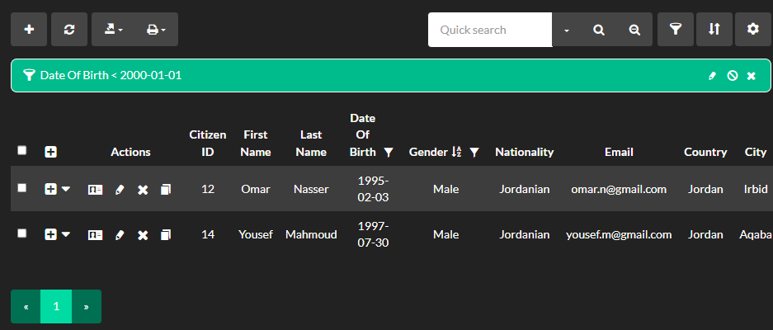

Edit filter disable filter reset filter

Multiple Sort

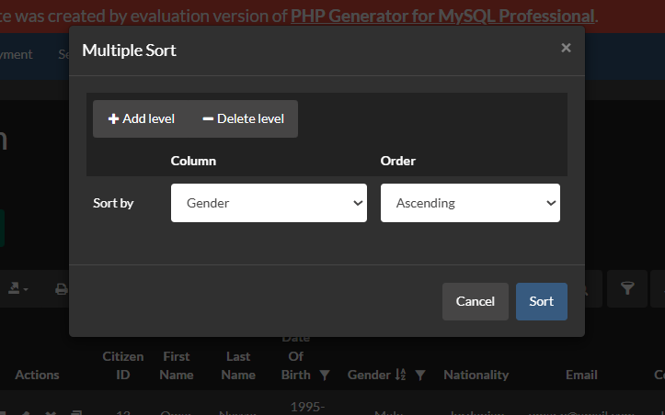
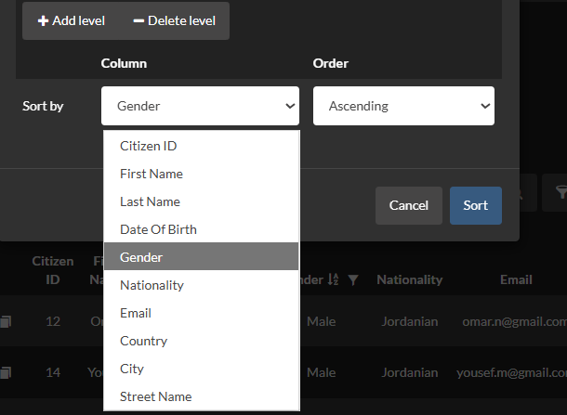
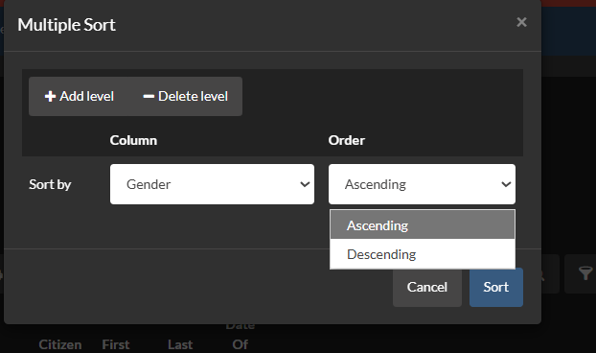
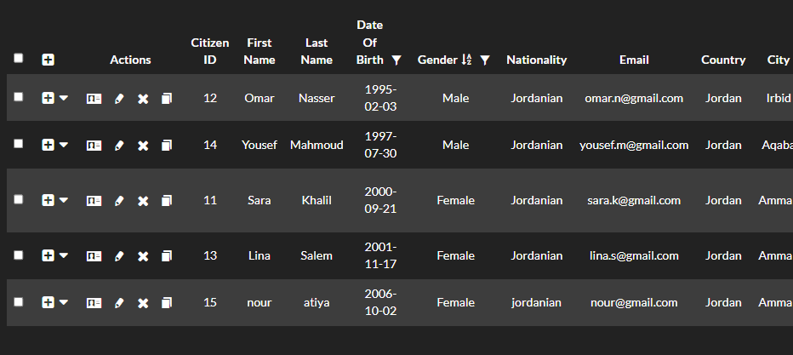
You can check service requests
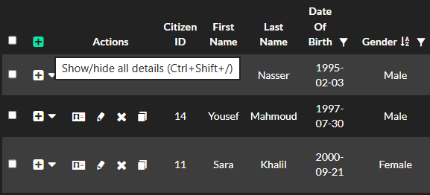
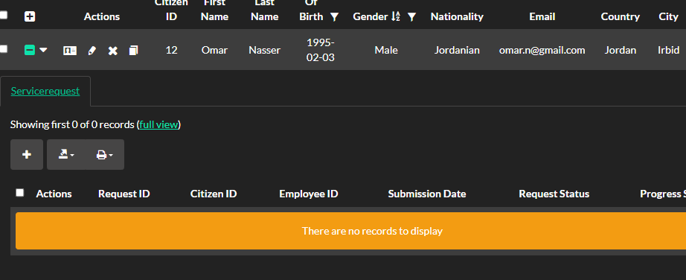
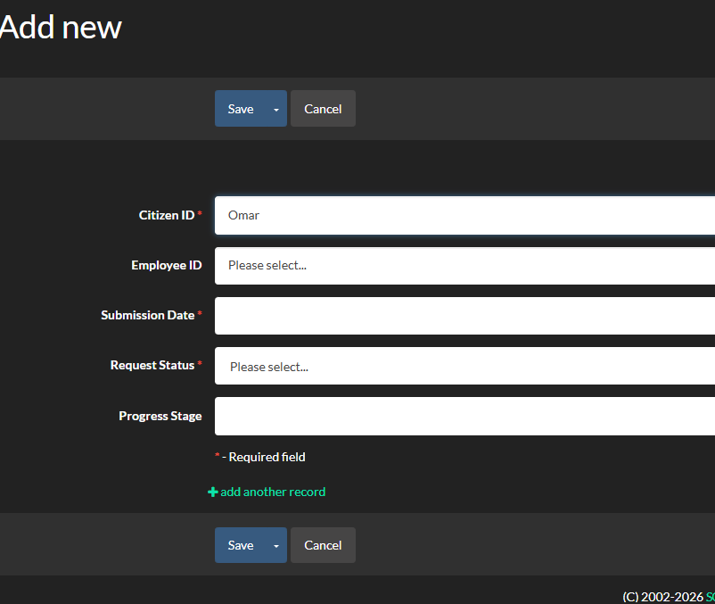
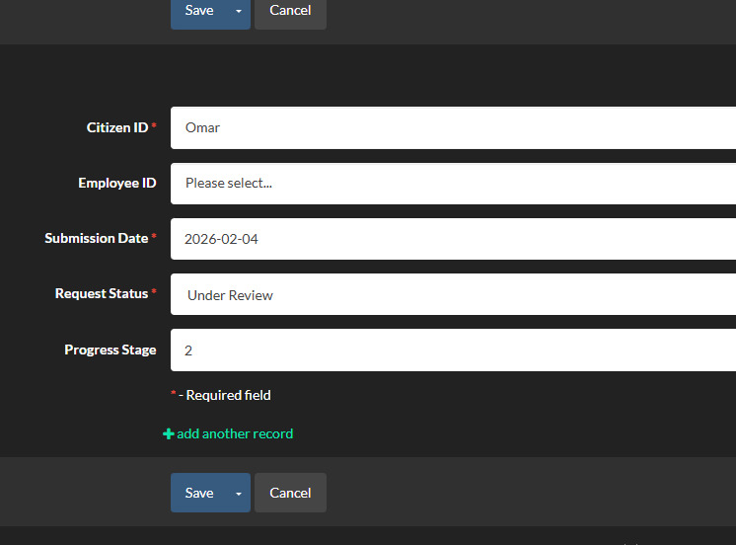
Note: all off these steps applied on all tables

Frequently asked questions
- How do I register as a new citizen in the system?
  - Click the Register button on the login page, enter your National ID and required personal information, and create a password.
- How can I submit a Personal ID renewal request?
  - After logging in, go to New Service Request, upload the required documents, and submit your request.
- Can I track the status of my request?
  - Yes, navigate to My Requests to see the current status (Pending, Under Review, Approved, Rejected, Completed).
- How do I make a payment for my service request?
  - Select the request and click Make Payment, then choose a payment method and complete the transaction.
- Can I update my personal information after registration?
  - Yes, go to Profile and edit your details. Make sure to save changes to update the database.
- What if I forget my password?
  - Use the Forgot Password option on the login page to reset it via your registered email.
- Who can view my submitted requests?
  - Only authorized employees and auditors can access your request information. Employees can process requests, while auditors can only view them.
- How do employees process requests?
  - Employees log in, review assigned requests, check documents and payment records, and update the request status accordingly.
- Can I see my payment history?
  - Yes, all payments linked to your request are visible under Payment History.
- Who should I contact if I face technical issues?
- You can contact the system administrator or support team using the contact details below.

Contact information
If you need assistance or have any questions regarding the SANAD Personal ID Renewal system, please use the following contact details:
- System Support Email: support@futuretech-jo.com
- Technical Support Phone: +962 6 555 1234
- Office Hours: Sunday to Thursday, 8:00 AM – 4:00 PM
- Address: FutureTech Innovations, Queen Rania Street, Amman, Jordan

